Abdulla Riza Wazeerdeen’s
Development Diary
Of CypherDeck

AI Usage Declaration
During the development of this project, I used Claude AI (Anthropic) for the following permitted purposes:

Database Population
- Generating placeholder test data for puzzles (titles, descriptions, categories)
- Creating dummy user accounts for testing leaderboard functionality
- Populating achievement definitions with icons and descriptions

Code Learning and Understanding
- Explaining programming concepts and methods (e.g., prepared statements, CSRF tokens)
- Clarifying how specific PHP/JavaScript features work (e.g., password_hash(), FormData)
- Understanding security best practices (session hijacking prevention, XSS protection)
- Learning about code conventions and naming patterns for cleaner code organization

Code Formatting and Organization
- Suggestions for consistent variable naming conventions
- Recommendations for comment formatting and code documentation
larification:
- No code was AI-generated or written by AI
- All problem-solving, debugging, and implementation was completed independently
- AI was used purely as an educational resource to understand methods and concepts
- All security implementations (CSRF, session management, password hashing) were coded by me after learning the underlying principles

CypherDeck Development Diary
Developer: Abdulla Riza Wazeerdeen
A-Level Computer Science NEA
Start Date:
Supervisor: Mr Taylor

Project Vision
CypherDeck began as a Matrix-inspired cryptography platform but has evolved into something more ambitious - a social-first puzzle community that combines the nostalgic community magic of Club Penguin with the intellectual rigor of platforms like HackTheBox. The vision is to create a "place" where tech enthusiasts solve puzzles together, share knowledge, and build genuine connections around shared challenges and myths.
The core concept centers around presenting puzzles as detective case files in a futuristic interface. Users work externally on challenges (no VMs or AI tools provided due to budget constraints) and submit answers through case file forms. The social element emerges through community "rooms," collaborative solving, and shared cultural experiences that build platform legends.

Development Log

Entry 0: The Class Prototype
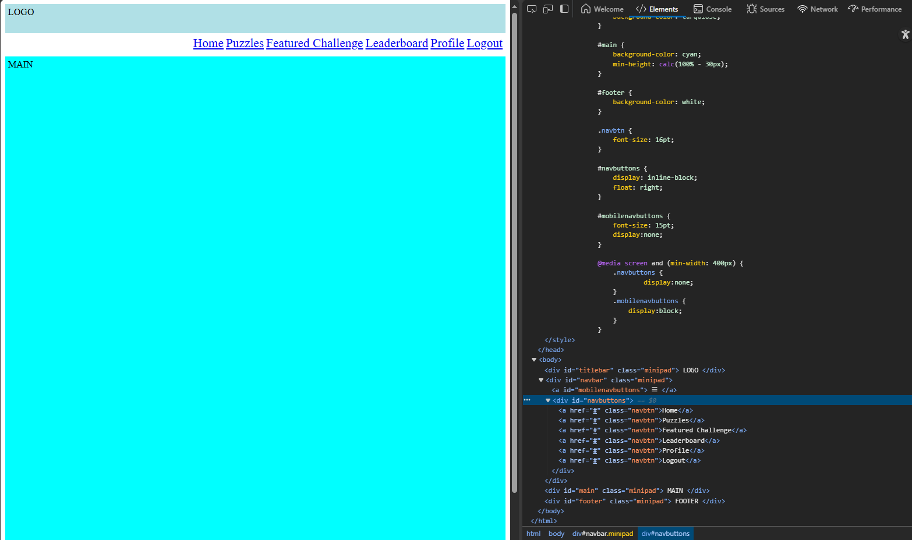
This is the initial state of the website, made in class, all from scratch as a basic way to visualise the layout of the site. It misses a decent chunk of the features of the site, and primarily focuses on trying to implement the 4 areas of the webpages:
- Header (Title + Logo)
- Footer (extra info like contacts)
- Main (holds the main content of the site)
- Navbar (Easy access of other parts of the website)
It also has a very basic implementation of responsive web design using CSS, but with no response from the navbar given that there are no sites to link to.

Entry 1: Foundation
I got started today by creating the basic HTML structure for the project. I know I'm going to need multiple pages, but for now I am going to make the index page. That way as I'm building a base template, I can get some form of visual representation. The template includes all the semantic HTML5 elements I've been learning about, plus the viewport meta tag for mobile responsiveness that I'll need later. It felt slow at first, but this template approach will save me time down the road.
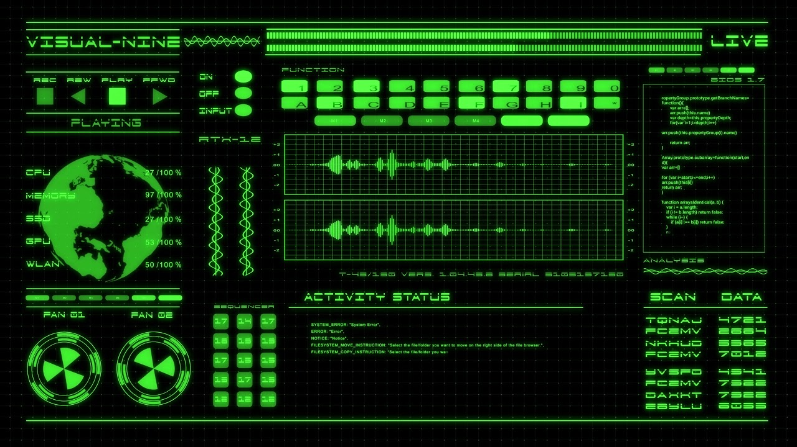
I had begun to make a rough idea of how i wanted to make the index page, and by doing so, the rest of the site, using my research from the Analysis Page. Namely I decided to emulate the Matrix terminals, or in essence a “Dark Mode” of Google CTF.
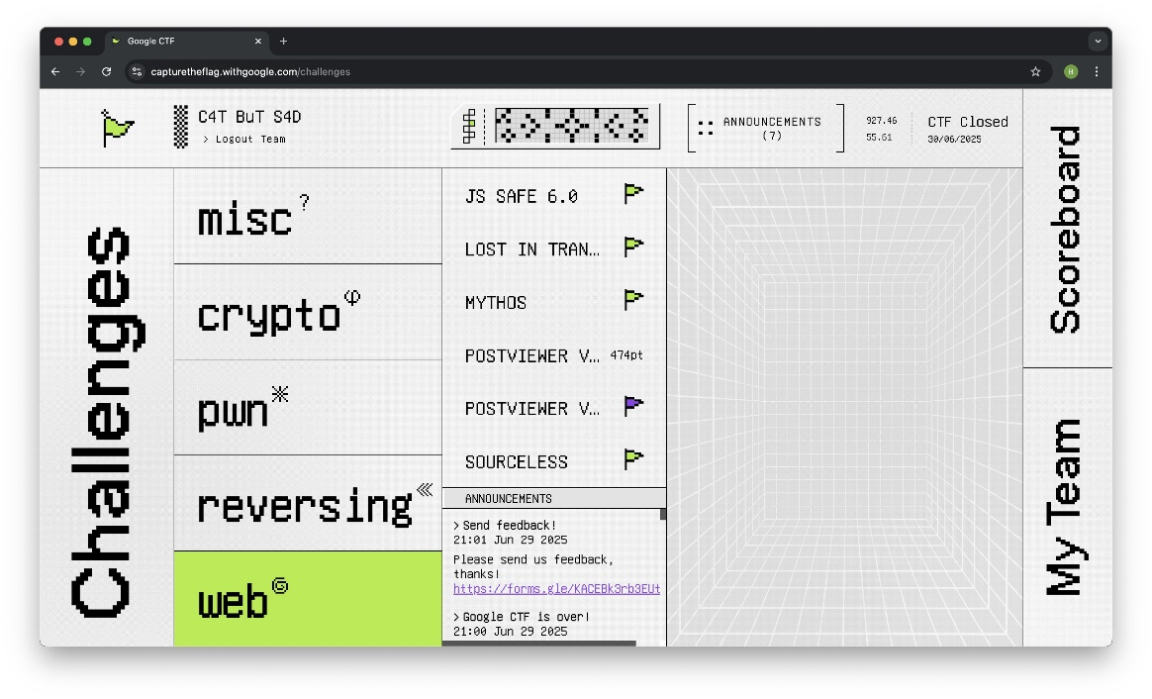
I wanted to make the website to have the ability to perform reactive tasks to the user’s actions, like for example how the co-ordinates of the page change. I also loved the colour scheme of Glowing Green Text on a black background, even though it is rather cliché, it is something I can update later, for now I just need a somewhat functioning prototype, then I can do some redesigns.

Entry 2: Custom Navigation Implementation
Iteration 1:
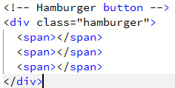
The focus of today was the Navbar and Navigation between pages in general. The hamburger menu functionality required JavaScript event handling that I'm still getting comfortable with. My initial prototype for the hamburger menu uses 3 span tags layered one above the other, positioned on the navbar container, aligned to the right of the page.
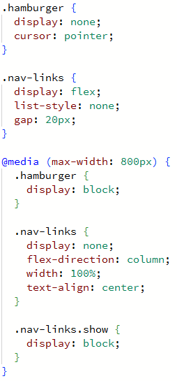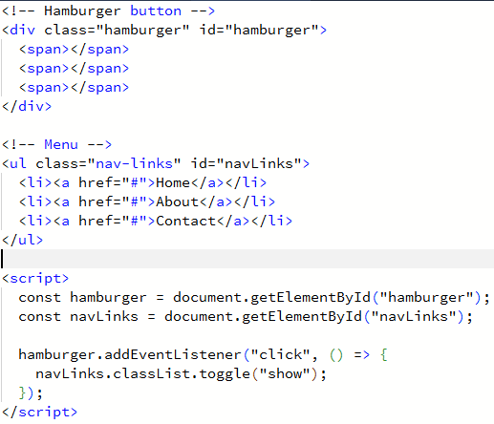
Iteration 2: For my second iteration, I used a JavaScript script to find the Nav Links and the hamburger span tags. It then applies an event listener so that when the user clicks the hamburger button, a class is toggled on the list to “show” it. This makes use of the CSS class list property, which allows classes to be added or removed dynamically. While this works, I’ve noticed inconsistent behaviour across different screen sizes. Because the functionality depends on a manually toggled class, if the CSS media queries are even slightly misaligned, the menu can either remain hidden when it should display or overlap other elements in ways that make the layout harder to use.
This showed me how quickly small details can pile up into bigger problems. I’m planning to look into CSS frameworks next, purely for ease of development. Building this custom version helped me understand the mechanics behind responsive navigation, but I also see the value in using established tools that save time and reduce the chance of these issues.

Entry 3: Framework Research and Testing
To improve responsive navigation, I researched three major CSS frameworks: Bootstrap, Tailwind CSS, and Foundation.
Bootstrap: The prototype used the navbar-expand-md, ms-auto, and navbar-toggler classes. These provided a responsive, collapsible menu with minimal effort. The class names were intuitive, and the component worked reliably without additional debugging.
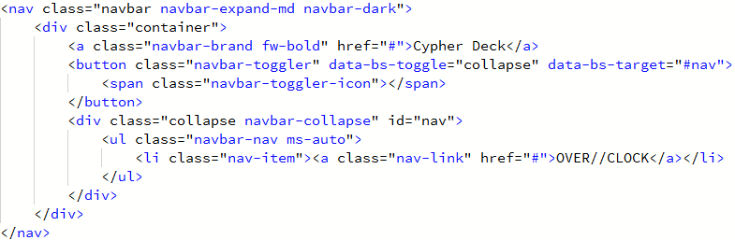Tailwind CSS: The Tailwind prototype relied on utility classes such as flex justify-between items-center. These provided precise control over layout, and the syntax was compact. However, the large number of utility classes required felt like learning a new system on top of CSS, which slowed progres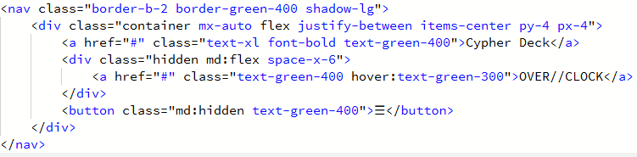Foundation: The Foundation prototype used semantic structures such as <div class="top-bar">. This encouraged better HTML organisation and grid usage. While this approach would improve long-term structure, it was more demanding and less accessible given my current experience level.
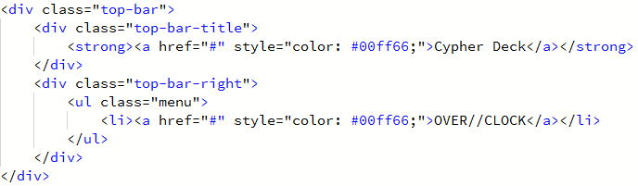After testing each framework, I chose Bootstrap because it balanced accessibility with robust functionality. It allowed me to focus development time on unique features and design choices rather than troubleshooting CSS responsiveness.

Entry 4: Bootstrap Integration
Replaced my custom navigation with Bootstrap's navbar component and immediately felt the improvement. The responsive behavior just works without all the debugging headaches I was dealing with before. Started developing the Matrix aesthetic today too. Added the cyberpunk green-on-black theme with some strategic CSS:
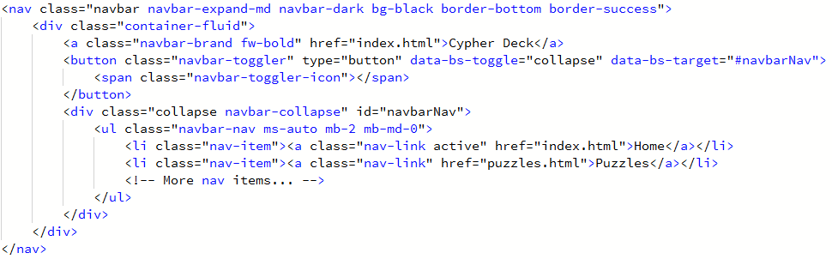
It may not look too different in the surface, but it saves a lot of time. And will be compounded on as we go on.
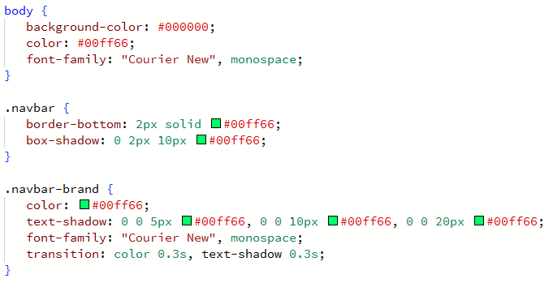
The glow effects are coming together nicely. Used box-shadow and text-shadow to create that Matrix-style underglow, plus Courier New for the monospace typography. The whole thing is starting to look like something from a sci-fi movie rather than just another boring website.

The time saved with Bootstrap is incredible. Instead of debugging for hours, I was able to focus on the visual elements that make this project unique. The framework handled all the complex collision detection and mobile menu logic while I concentrated on the cyberpunk theming.
Key Bootstrap classes that saved my sanity:
- navbar-expand-md - automatic mobile collapse behavior
- ms-auto - pushes nav items to the right edge
- container-fluid - responsive full-width layout
- btn-outline-success - perfect for the Matrix green theme

I had began reading the bootstrap 5 documentation and making md files as a means of cheat sheeting, plus noting things down does help:
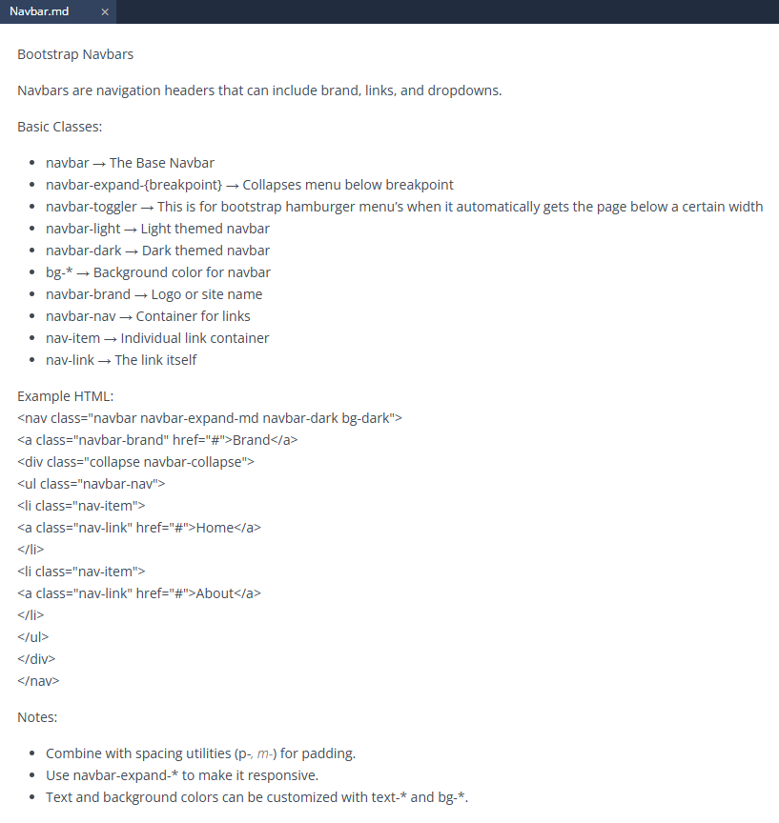

Entry 5: More Bootstrap Notes
After integrating Bootstrap’s navbar, I reviewed its layout systems in greater depth to ensure I understood the framework fully. I focused on three areas:
- Containers: Tested the difference between container and container-fluid. Using container-fluid improved scaling across screen sizes, ensuring the layout remained consistent on both desktop and mobile.
- Spacing utilities: Applied margin and padding classes (m-* and p-*) to standardise spacing between components. This simplified CSS management and produced a cleaner layout.
- Grid system: Experimented with the grid layout to structure content more efficiently, replacing multiple nested <div> elements with a clearer row/column organisation.
I also used Bootstrap’s typography utilities to refine text styling and applied the spacing system to the main content box. The content box was then styled with a green glow against the black background to match the Matrix-inspired aesthetic.
This deeper understanding of Bootstrap reduced my reliance on custom CSS and provided a consistent, maintainable structure for future development.
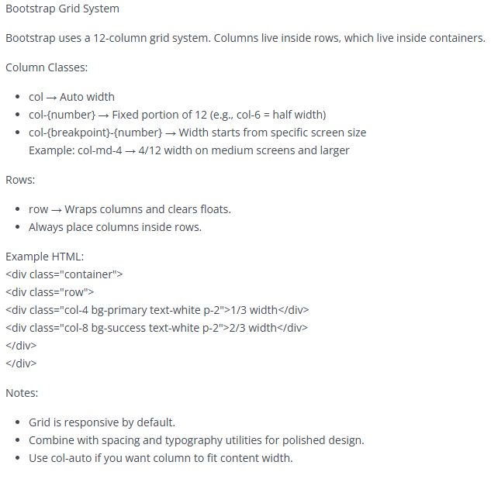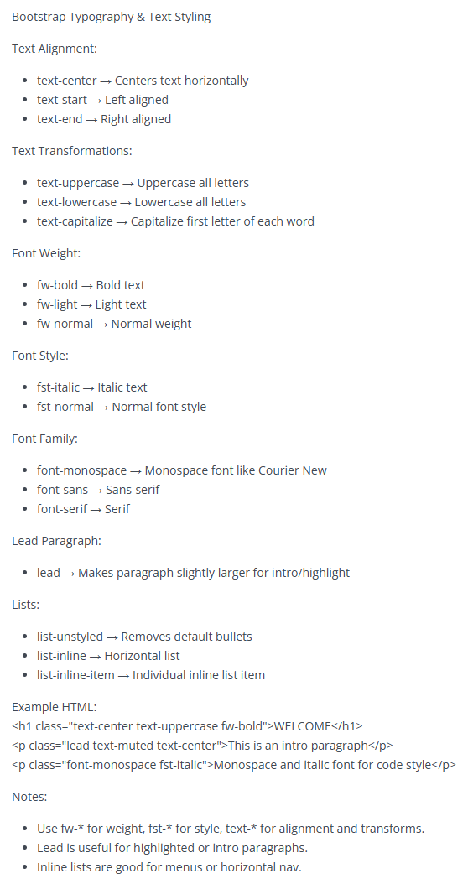
Also implemented the main content box styling:
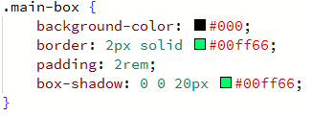
The green glow effect against the black background is exactly the Matrix aesthetic I was going for. These documentation sessions took time but I can already feel how much more confident I am with the framework.
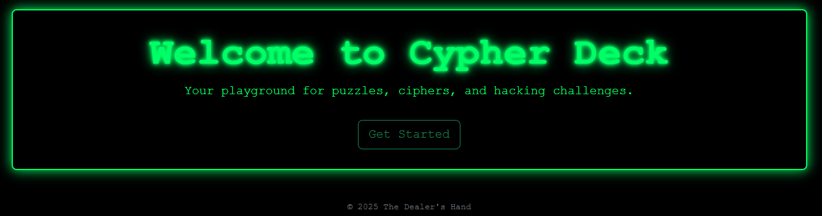

Entry 6: Aria
While examining Bootstrap’s navigation component in more detail, I identified accessibility features included by default through ARIA (Accessible Rich Internet Applications) attributes. For example:
- The toggle button uses aria-controls to associate it with the collapsible content.
- aria-expanded updates dynamically to indicate whether the menu is open or closed.
- aria-label provides descriptive text for screen readers.
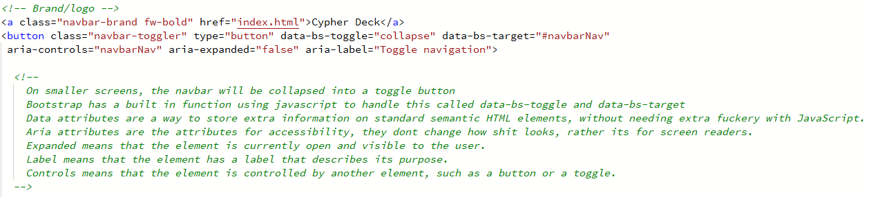
My earlier custom navigation lacked these attributes, meaning it would not have been accessible to users relying on assistive technologies. Bootstrap’s integration ensures that navigation is both responsive and accessible without requiring manual configuration.
Recognising this reinforced the importance of accessibility in the project. Since CypherDeck is intended as a community platform, ensuring usability for a wider audience is essential.

Entry 7: Dynamic Theming
To add flexibility to the interface, I implemented a dynamic theming system using CSS custom properties controlled by JavaScript. Users can switch between difficulty levels, and the system updates the colour scheme instantly across the entire interface, including borders, buttons, and glow effects.
Four schemes were created: green, yellow, red, and cyan. To prevent abrupt visual changes, smooth CSS transitions were applied to properties such as border-colour and box-shadow.
This feature made the site feel more interactive and provided a foundation for future customisation. While currently linked to difficulty levels, the same system can later support user-defined themes or special event designs.
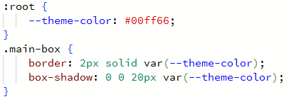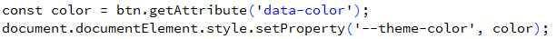
The OVER//CLOCK mode now switches between green, yellow, red, and cyan themes instantly when users select different difficulties. Each theme changes the entire page - borders, glows, button colors, everything. It feels like the interface is actually responding to user choices rather than just displaying static content.
This dynamic theming system is definitely going to extend beyond just OVER//CLOCK. I can see using it for user customization, special events, even different moods for different types of puzzles.

Entry 8: Backend Authentication
I began developing the backend authentication system using PHP and MySQL. The goal was to allow users to register, log in, and eventually access personalised features such as profiles and puzzle creation.
The registration form now securely stores passwords using PHP’s password_hash() function, which automatically applies a strong hashing algorithm. At first I thought password_hash() just used bcrypt permanently, but after reading the PHP docs I realised the algorithm can change over time. That explains why sites sometimes force password resets years later, something I’d never really questioned before.
This prevents raw passwords from being stored in the database. For login, password_verify() is used to compare the entered password with the stored hash. This approach avoids the security risks of older methods, such as MD5 or SHA1 hashing. To protect against SQL injection, all user inputs are sanitised using $conn->real_escape_string(). This ensures that special characters entered fields such as “username” cannot be used to alter queries maliciously.
A major debugging step involved correcting an SQL query. The registration form initially failed because the query referenced a table named users, when the database contained Users (capitalised). After fixing this, registration and login functioned correctly, and new accounts were successfully stored in the database. To prepare for role-based access control, I added a simple check: if a user’s role is “admin,” they are redirected to a placeholder dashboard. This will later expand into functionality that allows administrators to create or manage puzzle rooms.
The next task will be implementing PHP sessions. These will store user IDs or tokens during login, allowing persistent access across multiple pages and enabling personalised features such as puzzle progress tracking.
This was around the time tutorials introduced me to prepared statements:
This automatically handles escaping and prevents SQL injection. I intend to use this pattern everywhere from now on. Also added password strength requirements while I was at it:
- Minimum 8 characters
- At least one uppercase letter
- At least one lowercase letter
- At least one number
Created a validation function that checks these with regex before allowing registration.

Entry 9: Bug Fixing and Design Revelation
While refining the OVER//CLOCK dynamic theming system, I noticed abrupt jumps in the glow effects when switching between colour schemes. This was due to CSS properties changing instantly without transition effects.
To fix this, I applied CSS transitions to the .main-box element:
This ensured that both border colours and glow effects fade smoothly between states. Testing confirmed that the transitions made the interface more visually appealing and less distracting during difficulty changes.
During this debugging process, I realised that the theming system was more versatile than initially planned. Instead of only supporting a green Matrix-style aesthetic, it could be extended to multiple colour palettes. This opened the possibility of broadening the project’s visual identity to better align with its detective and sci-fi theme.
As a result, the theming system is now considered a core feature of the interface. It supports future additions such as user-selected themes, seasonal events, or community-driven customisation.

Entry 10: Design Philosophy Rethink
After refining the theming system, I evaluated the overall design philosophy. The Matrix-inspired green-on-black aesthetic was effective, but restrictive. I decided to broaden the style to include sci-fi HUD influences with layered panels and varied colour palettes.
To explore this new direction, I created a small prototype in CSS with an alternative cyan theme and adjusted typography weights to test readability under different glow levels:
These experiments confirmed that additional palettes would work within the current system without breaking responsiveness or accessibility.
The outcome was a design shift: retain terminal-style elements (monospace text, glow effects) while allowing more flexible sci-fi-inspired theming.
Though I now do realise this would be not the most effective use of my time given the limited scope / timing of my project, this may seem too ambitious for the most part, so I would rather be focusing on the core features.

Entry 11: Community Vision Planning
I planned the community features of CypherDeck around a detective theme, presenting puzzles as case files and using a SOCIAL tab for collaboration in themed discussion rooms.
To test the feasibility, I drafted wireframes showing the layout of the SOCIAL tab with sample rooms such as a Cryptography Den and Steganography Lab. A simple HTML prototype validated that the navigation structure could support these spaces:
This mockup demonstrated that users could switch between puzzle-solving and community spaces without breaking immersion.
The outcome of this planning was a clear decision: implement detective-style puzzle menus and social rooms, supported by a consistent interface design. I also considered adding an optional VHS filter overlay as a shader effect, giving users the choice between a clean futuristic interface or a more retro-cyberpunk aesthetic. Together, the detective theme and collaborative features create an experience that feels distinct from existing platforms.

Entry 12: Adding Functionality to Login and Register, and some PHP Template shenanigans
I also tested the PHP template system by converting the navigation into a reusable include file. This confirmed that changes in one file propagate correctly across all linked pages, improving maintainability.
When I updated header.php, the changes were automatically reflected on all pages, confirming the benefit of using includes.
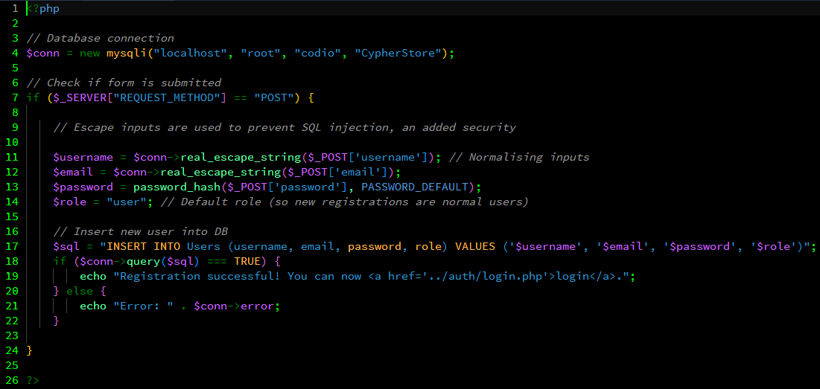
I had spent far too long trying to troubleshoot why my register page wouldn’t store my login information. It was because of the most infuriating thing: the SQL query to the table users wouldn't have worked, since “users” doesn't exist. “Users” does though. After a brief contemplation of life choices, I had tested once again the register php, which works.
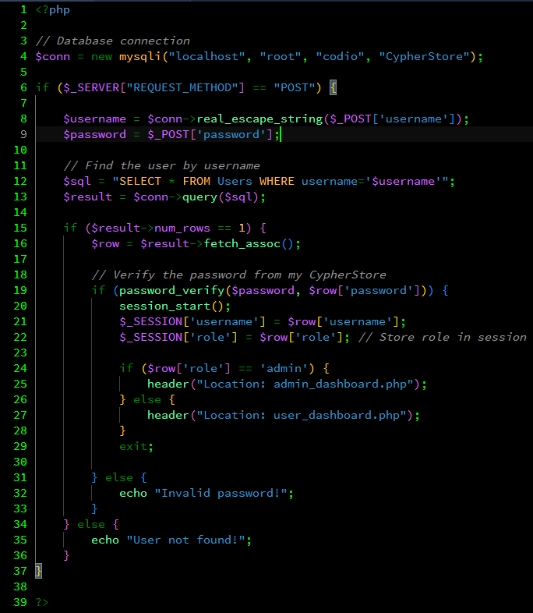
I've made a basic if statement to say that if the role of the user is admin, they go to the admin dashboard, as a placeholder, I do need to make functions for making or verifying admin status of a user, allowing them to access the rooms creation function. For now thought, I am researching sessions, which stored user information making it persistent across multiple pages. In that way, we get the whole “logged in” part of my site, being now able to access the profile, make and edit your puzzles e.c.t.

Entry 13: OOP Code
I created userClass.php and tried to make a User class. My first version looked like this:
When I tried to use it in my login script:
Nothing showed up with this iteration. As it turns out, I forgot $this-> in the constructor. The variables were just local to the constructor function, not actually being assigned to the object properties. I then ran into another issue:
This worked, but then I realized anyone could just do $user->username = "admin" and change it directly. This was a security oversight, that could lead to the whole site breaking, given admins have access to making and managing the social rooms, puzzles and events. After reading more about encapsulation I redid it properly:
The private keyword means these properties can only be accessed from inside the class. Now if I want to get the username, I have to use $user->get_username() instead of accessing it directly. This gives me control over how the data is accessed.
I also added a default parameter $ut=1 so if someone forgets to pass the usertype, it defaults to the regular user instead of breaking. Learned that after forgetting to pass it in a test and getting an error about missing arguments.
As of now the class is very basic, I still need to add methods for stuff like checking permissions or getting solved puzzles. But it's a start and way better than passing arrays everywhere. Now to make this usable, we have to load user data from the database, not just store strings.
By keeping properties private and exposing only specific methods, you can prevent accidental or unsafe changes to important state, such as user roles or permissions.
As the project grows, this structure reduces bugs, avoids duplicated security checks, and keeps it all maintainable instead of collapsing into scattered arrays and fragile procedural code.

Entry 14: Relative Paths
I have files at different levels, so when I was in login.php and tried to link back to home with <a href="index.php">Home</a>, it would try to go to pages/auth/index.php. Which doesn't exist. Hence would return a 404 error. So I changed it to <a href="../../index.php">Home</a>. But then when I used the same navbar on puzzles.php, it tried to go UP two directories from there and completely broke.
The reason I'm using so many folders is simply for my own sanity, and sake or organisation of the file system. After searching up "html relative paths different directories", I found the <base> tag:
Now all paths are relative to /cypherdeck-main/ no matter where the file is located. It's a simple mater but it would save on headaches in future.
- href="index.php" = /cypherdeck-main/index.php
- href="pages/auth/login.php" = /cypherdeck-main/pages/auth/login.php
I added it to every page and suddenly all my links worked. The base tag doesn't work for PHP includes. So, require_once() calls were still breaking.
I made a little comment in each file noting how many levels deep it is so I don't mess this up again.

Entry 15: Puzzle System: Relational Databases
Today I focused on designing and implementing the database schema to support the puzzle system. I've worked with SQL in class exercises, but creating a complete relational schema (a blueprint of the relational database) for a real application required more careful planning.
I started with the Users table since the authentication system was already partially implemented. I opened PHPMyAdmin and created the table structure:
This executed successfully on the first attempt. The table now stores user credentials with a role field to distinguish between regular users and administrators. The password field uses VARCHAR(255) to accommodate the hashed passwords generated by PHP's password_hash() function. Now for puzzle data, I’ve consolidated everything into a single PuzzleStore table:
The difficulty field uses an ENUM to restrict values to predefined options. This prevents invalid difficulty levels from being stored and makes querying by difficulty more efficient. I chose 'Easy', 'Medium', and 'Hard' as these are more universally understood than my OVER//CLOCK difficulty names, though I may map these in the frontend display.

I thought this would work because most puzzles would have 1-3 questions, and having everything in one row would be easy to retrieve. However, I quickly realized this approach had several problems. The design imposed a fixed question limit, so if a puzzle needed 5 questions or 10 questions, I'd have to keep adding columns. Puzzles with only 1 question would leave question2 and question3 empty, wasting database storage. Getting all questions for a specific puzzle would require checking question1, question2, and question3 separately, making queries complicated. Adding or removing questions after puzzle creation would be difficult to manage.
I realised that I was repeating the same data structure (question/answer/hints) multiple times in a single row, which was a sign I needed a separate table.
He advised me to split the design into two tables. The first table, PuzzleStore, would store puzzle metadata like title, description, and difficulty. The second table, PuzzleQuestions, would store individual questions, each linked to a puzzle via foreign key. This would allow unlimited questions per puzzle, eliminate wasted space, and make queries much cleaner.
The difficulty field uses an ENUM to restrict values to predefined options. This prevents invalid difficulty levels from being stored and makes querying by difficulty more efficient. I chose 'Easy', 'Medium', and 'Hard' as these are more universally understood than my OVER//CLOCK difficulty names, though I may map these in the frontend display.
I used PHPMyAdmin's Relation view to add the foreign key constraint, setting it to INNODB with the database CypherStore, referencing the Users table's id column. I left ON DELETE empty initially and set ON UPDATE to RESTRICT. After adding this constraint, I tested by attempting to insert a dud puzzle with a non-existent user ID:
"Error: Cannot add or update a child row: a foreign key constraint fails". The constraint is working as intended.
I used PHPMyAdmin's Relation view to add the foreign key constraint, referencing the Users table's id column. I left ON DELETE empty initially and set ON UPDATE to RESTRICT. That way deleting or adding some incorrect info as an admin won’t work, keeping the integrity of the database.
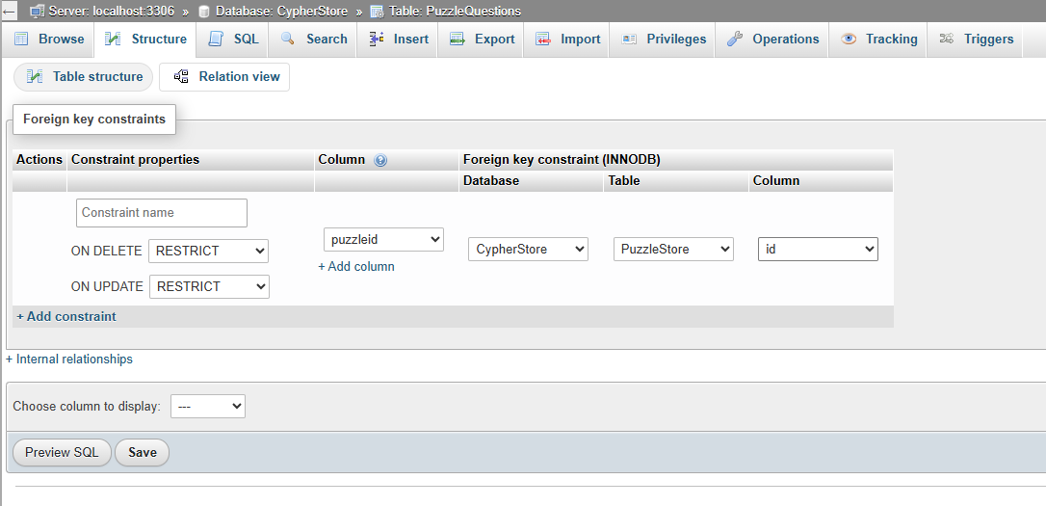
The three tables now form this structure:
- Users: Stores user accounts and authentication data
- PuzzleStore: Stores puzzle metadata (ready for puzzle creation feature)
- PuzzleQuestions: Stores individual questions within puzzles
Relationships:
- PuzzleStore created_by -> Users.id (one-to-many: one user creates many puzzles)
- PuzzleQuestions puzzleid -> PuzzleStore.id (one-to-many: one puzzle has many questions) so it needs foreign key constraint

Entry 16: Puzzle System: Asynchronous JavaScript Operations
After some research, Asynchronous JavaScript seemed that it could significantly improve the user experience for the puzzle-solving interface. Currently, when users submit answers, the entire page reloads, which feels clunky and interrupts the flow. I decided to research asynchronous JavaScript to understand how it could benefit CypherDeck.
The current answer submission process works like this:
- User fills in answer form
- User clicks submit button
- Form sends POST request to PHP script
- Page reloads completely
- PHP displays success or error message
This means every answer attempt requires a full-page refresh, which:
- Takes time (even if only a second or two)
- Loses the user's scroll position
- Feels dated compared to modern web applications
- Makes rapid-fire testing of different answers frustrating

Entry 17: Puzzle Creation Backend: First Implementation
After finalizing the database schema in Entry 15, I began building the backend logic for puzzle creation. Authenticated users submit puzzles via a form, which inserts data into both PuzzleStore and PuzzleQuestions tables.
My initial attempt used raw string interpolation, which quickly led to an SQL error and a critical security realization, it could terminate your INSERT statement and execute unwanted SQL, potentially deleting tables or exposing data.
“Error: Column count doesn't match value count at row 1. More importantly, I realized I had left $desc vulnerable to SQL injection through unescaped quotes.”
So, I redid the code to use prepared statements for security and stability.

Test Log
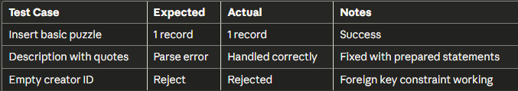

Entry 18: Dynamic Question Fields with JavaScript
With the backend stable, I moved to the frontend creation form. To support multi-question puzzles, I needed to make the question fields dynamic using JavaScript. My first addQuestion() function failed because I forgot to use array notation ([]) in the input names. Only the last question was sent to PHP because each input had the same name.
When I tested this, only one question appeared in the $_POST data on the backend. PHP needs unique names or array notation to handle multiple values, so I fixed this by adding [] array notation to the input names:
Now when the form submits, PHP receives $_POST['questions'] as an associative array where each index contains ['text'], ['answer'], and ['hints'] keys. This made the backend loop much simpler:
This a basic version. It doesn't handle removing questions yet, and there's no validation beyond the HTML required attributes. But it works for creating multi-question puzzles, which was the goal for this iteration.

Test Log
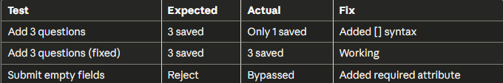
Working question empty field security:

Entry 19: Puzzle Display and JOIN Queries
The next step was displaying puzzles with their associated questions using SQL JOIN queries. I wrote a JOIN query to fetch question data:
This returned zero results even though questions existed in the database. Debugging revealed two issues:
- Some test puzzles had NULL values for puzzleid because I hadn't captured insert_id correctly
- The PuzzleQuestions table was using the MyISAM storage engine instead of InnoDB because of a misclick on my end, preventing foreign key constraints from working
After the conversion and re-inserting data with proper foreign keys, the JOIN worked perfectly.

Entry 20: Answer Validation and Regex Normalization
I implemented the answer-checking logic on solve_puzzle.php. The first version used a simple string comparison:
It was simple and effective, though it failed on trivial differences like extra whitespace, capitalization, and punctuation. But was a good start to show that the puzzle solving engine was connecting to the database. This improved Version uses trim() and strtolower():
Now currently I am banking on the fact that most questions won't have case sensitive answers regardless, but this is an oversight I will later. This was still insufficient for cases like "New York" vs. "NewYork". To counter this, I implemented regex-based normalization to strip all whitespace before comparison:
As showcased, the answer doesn’t need to be case sensitive, and as such, will show correct given the implementation:

Entry 21: Question Linking Bug and ID Capture
During testing, I found a bug: questions weren't linking to their parent puzzles correctly, resulting in orphaned questions. The root cause was that I was attempting to capture insert_id after the question insertion loop. I corrected the logic to capture the ID immediately after the PuzzleStore insert:
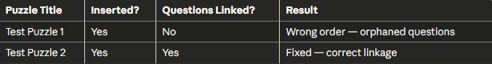

Entry 22: CSS Integration and Responsive Design Fixes
To unify the visual style across the entire platform, I needed a flexible theming system that could handle multiple game modes, difficulty tiers, and responsive layouts. I introduced CSS custom properties to enable runtime theme switching:
The --theme-color variable can be dynamically updated via JavaScript, which powers the OVER//CLOCK difficulty color changes. When users select "Thermal" difficulty, JavaScript updates this variable to red (#dc3545), and every element using var(--theme-color) instantly updates.
I split CSS into specialized files to keep things maintainable:
- style.php: Base styles for all pages (navbar, main-box, general layout)
- style_puzzle_solve.php: Solve page specific (timer, question cards, hint system)
- style_puzzles.php: Puzzle list (accordion, difficulty buttons, OVER//CLOCK menus)
- style_overclock.php: OVER//CLOCK mode theming
- room_style.css: Social rooms (windows, sticky notes, desktop grid)
I also implemented visual feedback for different puzzle states:
The .correct class gets applied when answers are validated, providing instant visual confirmation for the user. The overclock-* classes transform the puzzle card based on selected difficulty, giving each tier their own unique feel to it. Now to deal with the 2 major problems left:
- Long question text caused horizontal overflow on mobile. Text would break the container and create horizontal scrolling. I also added overflow-wrap to compensate for various content types:
- The OVER//CLOCK difficulty buttons stacked poorly on mobile.
I then added smooth transitions to make theme changes feel intentional rather than jarring:
The :not() selectors prevent hover effects from interfering when a difficulty is selected.

Entry 23: Search and Filter System
The puzzle list did need some filtering and sorting system, given the number of puzzles I plan to put in. I built a multi-parameter search system that handles text search, category, difficulty, puzzle type, and sorting while preventing SQL injection. My first attempt used string concatenation without proper parameter binding:
This worked but was insecure. I rewrote it using prepared statements with dynamic parameter binding (this also allows the user to have 1, or 2, or no filters applied, basically a variable amount, without breaking my SQL):
The $types string accumulates parameter types ("sss" means three strings). The $params array holds all values in the same order. Now for sorting, I added a default case to prevent undefined sorting behaviour:

We also need to bind parameters dynamically:
The ...$params is a spread operator which unpacks the array into individual arguments for bind_param(). Without it, you'd have to manually bind each parameter, which doesn't work for dynamic queries. I now needed the filter dropdown to show only categories that actually exist:
Then in the HTML:
The selected attribute preserves the user's choice after form submission. When users apply filters, the form needs to remember their selections:
html
Without the value attribute, the search box would clear after every search, which is frustrating.
Clicking this returns to the base URL with no query parameters, clearing all filters. I then tested several scenarios to ensure it could hold up:
- Special characters in search: O'Reilly: properly escaped
- Empty filters: All parameters blank → returns all puzzles
- Non-existent category: Manual URL manipulation with invalid category → returns no results (correct)
- SQL injection attempts: ' OR '1'='1 → safely escaped by prepared statements
The dynamic parameter binding approach proved flexible and secure. Adding new filters just requires expanding the if chain and parameter arrays.

Entry 24: Populating Test Puzzles and Rating System
To test the new search and filter system, I created 30 test puzzles covering all categories and difficulties. I also expanded the PuzzleStore table to include a rating system.
I wrote a PHP block to calculate and display the average rating using a visual star/half-star system:
This provides clear, visual feedback of the puzzle quality to users.

Entry 25: Bootstrap Accordion Layout
The puzzle list was cluttered. It was currently a list of items and their information, so it is currently a visual overload. It needed some general organisation and general nice look to it. With 70 puzzles, the page became overwhelming. I needed a way to show titles at a glance while hiding details until requested. So, I adopted Bootstrap's accordion component to provide a clean way to display puzzle details without cluttering the main puzzle list.
The structure uses a loop to create an accordion-item for each puzzle:

What good is this list without some details for the user, and hence why I chose the bootstrap accordion list, given it has a built-in drop-down menu for the metadata of the puzzle. I expanded the header to show key information at a glance:

Now users can see title, rating, tags, difficulty, and points without expanding anything. These were simple to implement and is another amazing benefit of Bootstrap. I then added custom CSS to override Bootstrap's default blue focus/active highlight to match my green/cyan theme.

Entry 26: Timer System for Overclock Mode
Today I tackled one of the most critical features of OVER//CLOCK mode: the countdown timer. The challenge was making it flexible enough to handle four different difficulty tiers while keeping the user experience smooth and responsive. Instead of hardcoding a single time limit, I decided to pull the time limits directly from the database, relying instead on the user to set the timer as they see fit. Each puzzle stores four different time limits corresponding to the difficulty tiers, with each new one it gets shorter:
This approach gives puzzle creators full control over timing. A simple cipher might have generous time limits (300s base, 240s turbo), while a complex forensics challenge might need tighter constraints (600s base, 480s turbo).
My first timer implementation just showed raw seconds: "285s". It worked but proved to be unpolished. Users struggled to quickly assess how much time they had left. I rewrote the display logic to show minutes and seconds separately:
Now the timer displays as 04:45 instead of 285s, which is instantly readable and feels professional. The padStart(2, '0') method ensures single-digit numbers get a leading zero, maintaining visual consistency. The timer initialization happens when the page loads, but only if we're actually in OVER//CLOCK mode:
The warning state at 30 seconds adds a visual pulse effect (defined in CSS) that makes the timer flash red. It's a subtle but effective way to create urgency without being obnoxious. When time runs out, I lock the puzzle and redirect users back to the puzzle list:
This prevents any last-second answer submissions after time expires, which felt like the fairest approach. The 2-second delay gives users time to process what happened before being redirected.
By pulling time limits from the database rather than hardcoding them, I made the system infinitely more flexible. Puzzle creators can fine-tune difficulty curves for their specific content. A steganography challenge might need more time than a Caesar cipher, and now that's extremely simple to implement.
The MM:SS format was a small change that had a huge impact on usability. During testing, users could instantly gauge whether they had enough time to attempt another question or needed to speed up. The warning state at 30 seconds creates tension without panic. It's that perfect sweet spot where users feel the pressure but aren't overwhelmed by it.

Entry 27: Anti-Tab Switching and Hint Restrictions
To make Overclock Mode more challenging, and as an added bonus to stop any google searching of answers, I added two key restrictions: penalties for switching browser tabs and restrictions on hint usage. I used the “visibilitychange” event listener to detect when the user leaves the tab:

The toggleHint function now checks the restrictions array:

Entry 28: Major Overclock Rework: Mini vs Full Puzzles
I realized the single Overclock concept was too broad and lacked flexibility for different puzzle types. That and with working on the timer feature, it seemed that it would also be suitable as an added option for a challenge even for normal puzzles. The original implementation treated all puzzles the same way, which didn't work well for quick cryptography challenges versus longer multi-stage investigations. So, I split the timed challenge system into two distinct modes that better serve different puzzle formats:
- Overclock Mode: Timed challenge for full puzzles with multiple questions. Users select a difficulty level (base/turbo/hyper/thermal) which adjusts the time limit and point multiplier. Perfect for complex puzzles like web exploitation or forensics cases that require multiple steps.
- Burst Rush Mode: Rapid-fire challenge for mini puzzles, where each puzzle has a single question. Users face a continuous stream of random mini-puzzles under time pressure, with streak bonuses for consecutive correct answers. This works great for quick cipher decryptions or single-question cryptography challenges.
I updated the PuzzleStore table to support both puzzle types and their different scoring mechanisms:

The puzzle_type field determines whether a puzzle appears in Overclock or Burst Rush. The is_burstrush flag specifically marks puzzles eligible for the rapid-fire mode. This separation lets puzzle creators choose the intended experience when they upload content.
Now with the new Burst Rush interface, I needed a way to continuously serve random mini-puzzles without repetition within a session. I implemented a session-based tracking system that fetches one puzzle at a time:
When a user completes a puzzle, the system stores the puzzle ID in the session and excludes it from future selections during that run. This ensures variety without database overhead from tracking completed puzzles permanently until the session ends, thus improving performance.
I needed to verify the timer worked reliably under different conditions, so I ran several tests:
- Timer Accuracy: Set a 60-second timer and verified it against Windows 11’s stopwatch. The JavaScript setInterval() isn't perfectly precise, it drifted by about 200ms over 5 minutes due to browser tab throttling. This is acceptable for puzzle-solving where exact milliseconds don't matter.
- Tab Switching Detection: Opened the puzzle in one tab, switched to another tab, came back. The visibilitychange event fired correctly and applied the 30-second penalty. However, I discovered that if you switch tabs rapidly (within 1 second), multiple penalties could stack. Fixed this by adding a cooldown:
- Browser Compatibility:

Chrome/Edge: Works perfectly
Firefox: Timer occasionally skips a second due to different setInterval() implementation - acceptable variance
Safari: Required explicit event.preventDefault() in the tab switch handler
- Time Expiration Edge Case: What happens if a user submits an answer the exact moment the timer hits zero? Added a check in the answer submission handler:

Entry 29: JavaScript Color Theming System
I wanted users to see the interface transform when they picked a difficulty, reinforcing their choice visually before they even started the puzzle. When users click a difficulty button, several things need to happen simultaneously: remove previous styling, apply new colors, highlight the selected button, reveal the start button, and update the points calculation.

The data-base-points attribute stores the original point value so we can recalculate the final score when restrictions change later. Storing it as a data attribute means it's always accessible without querying the database again.
Now, the points system needed to account for both difficulty multipliers and restriction bonuses. This would provide a visual feedback for the user when points are earned.
Breaking down the calculation visually helps users understand exactly how their score is determined. They see Base: 100 → Multiplier: 2.0x → Bonus: +50 → Total: 250.
Once everything is configured, the start button triggers the actual navigation with all selected parameters encoded in the URL, which we had helpfully covered in class a lesson prior:
Passing the colour in the URL ensures the solve page maintains the exact same theme the user selected. Without this, there'd be a jarring visual disconnect between selection and gameplay. The instant visual feedback makes difficulty selection feel significant. When you click "Thermal", the entire puzzle card glows red and the points display updates to show 2.5x multiplier.

Entry 30: Points Calculation System
I built a dynamic points calculator that updates in real-time as users select restrictions.
This function runs every time a user checks or unchecks a restriction checkbox. It calculates the bonus points (+25 for each active restriction) and immediately updates the displayed total.
The backend calculation mirrors the frontend logic:
The backend verifies the frontend calculation to prevent client-side manipulation. Even if someone tries to fake their restrictions in JavaScript, the server recalculates everything from scratch using the restrictions passed in the URL.
Users see exactly how many points they'll earn before starting. The +25 bonus for each restriction encourages skilled players to challenge themselves without forcing it on everyone. Frontend displays are always verified server-side.

Entry 30.5: Scoring System for BurstRush
BurstRush required a completely different scoring approach than standard or OVER//CLOCK modes. Instead of points-per-puzzle, it needed per-question scoring with streak multipliers to reward sustained accuracy.
Unlike standard puzzles (fixed point reward) or OVER//CLOCK (time-based multipliers), BurstRush needed:
- Points awarded per correct answer, not per puzzle
- Streak bonuses that increase with consecutive correct answers
- Real-time score updates as users progress through questions
- A cap on multipliers to prevent infinite scaling
First, I updated the PuzzleStore table to support BurstRush-specific scoring:
This allowed puzzle creators to define:
- points_per_question: Base points for each correct answer (typically 10-50)
- max_questions_per_session: How many questions appear in one run (5-50)
- time_limit_per_question: Seconds allowed per question (5-60)
I also created the BurstRushSessions table to track active gameplay:
The core of BurstRush scoring is the streak multiplier system. Each consecutive correct answer increases your multiplier, capping at 2.5x:
Each correct answer adds 10% to your base multiplier:
- 0 streak: 1.0x (base points)
- 3 streak: 1.3x
- 5 streak: 1.5x
- 10 streak: 2.0x
- 15+ streak: 2.5x (capped)
Without a cap, long streaks could produce absurdly high scores that break leaderboard balance. The cap ensures skilled players are rewarded but not to an exponential degree.
Now when a user submits an answer, the backend processes it and returns all the data needed to update the UI:
The frontend receives this JSON and immediately updates the stat cards at the top of the page:
The most important rule: any wrong answer resets your streak to zero:
This forces players to balance speed (answering quickly) with accuracy (maintaining the streak). One mistake costs you all momentum.
When a BurstRush session ends (either by completing all puzzles or time expiring), the final score is recorded to the leaderboard:
The ON DUPLICATE KEY UPDATE ensures that if a user plays the same BurstRush puzzle multiple times, only their best score is saved. This prevents score inflation from repeated attempts.
Unlike OVER//CLOCK (which multiplies final score), BurstRush uses time pressure as its difficulty mechanic:
Higher difficulties don't change point values, rather they give you less time to think. This prioritises a player’s skill and ability to answer quickly and accurately.
The BurstRush leaderboard shows total points and best streak for each player:
This query pulls:
- Total points: Sum of all BurstRush scores
- Best streak: Highest streak ever achieved
- Puzzles solved: Count of unique puzzles completed
After completing a BurstRush session, users see a detailed breakdown:
This gives immediate feedback on performance and encourages improvement.

Entry 31: Toggle Overclock Menu Animation
The menu to select Overclock options needed smooth show/hide transitions. The initial version used an instant display toggle.
I refactored the function to manipulate opacity with a setTimeout delay:
This, combined with a CSS transition, creates a smooth slide-and-fade effect.

Entry 32: Start Overclock Function with URL Parameters
The final step was the startOverclock function, which launches the puzzle with all selected settings. The function gathers the selected difficulty and restriction states and constructs a URL:
The solve_puzzle.php page reads these parameters to initialize the state:

Entry 33: User Progress Tracking Database
I spent a lot of time today rethinking how to track user progress. My initial plan was to create a per-question tracking system, but after implementing the multiple game modes (Standard, OVER//CLOCK, Burst Rush), I realized that approach wouldn't scale well.
Originally, I wanted to track every single question attempt:
- Which question was answered
- How many attempts it took
- Whether hints were used
- Timestamp of completion
This works great for a single-mode system, but with three distinct gameplay modes, it creates problems:
- Users can solve the same puzzle in Standard, then again in OVER//CLOCK (thermal), then again in Burst Rush
- Each mode has different scoring rules
- Tracking every question creates massive database bloat (10 questions × 3 modes × 100 puzzles = 3,000+ rows per user)
I pivoted to a dual-table approach that separates aggregate statistics from detailed solve history.
UserProgress stores high-level user statistics:

The expertise_tag field automatically gets set based on which puzzle categories users solve most frequently, which creates an organic progression system.
SolvedPuzzles stores detailed per-attempt records:
This table captures mode-specific details:
- Standard mode: Basic completion with points
- OVER//CLOCK mode: Time taken, difficulty tier, restriction bonuses
- Burst Rush mode: Streak count, questions correct, session performance
The UNIQUE KEY unique_standard_solve (user_id, puzzle_id, mode) constraint is critical. It prevents duplicate solve records while allowing users to attempt the same puzzle in different modes for different scores.
When a user completes a puzzle, two database operations happen:
1. Record the specific solve in SolvedPuzzles:
The ON DUPLICATE KEY UPDATE clause handles retries. If a user solves the same puzzle again in the same mode (maybe trying for a better OVER//CLOCK score), we update their record rather than creating duplicates.
2. Update aggregate statistics in UserProgress:
This aggregates their totals by having all their SolvedPuzzles records. The subqueries ensure the counts are always accurate even if solves are deleted or modified. The expertise tag was an unexpected benefit of this design. By analyzing which categories appear most in a user's SolvedPuzzles, I can automatically badge them as "Cryptography Expert" or "OSINT Specialist" without any manual tagging system. This proves beneficial for my goal to create a more connected community here and will link into the social rooms feature.

Entry 34: Form Submission Without Page Reload
I initially considered full AJAX for answer checking but ultimately opted for a simpler form submission approach with dynamic feedback. The JavaScript prevents the default form action briefly to show a loading state:
I added a CSS keyframe animation called shake for wrong answers:

Entry 35: Database Time Limits
The final implementation step was adding time limit columns to PuzzleStore for each Overclock difficulty tier. This allows each puzzle to have a unique timer setting based on its complexity:
I rebuilt the homepage to properly introduce the project's ecosystem and its three distinct game modes:

Entry 36: Making the Leaderboard
The leaderboard is a competitive feature that displays top players across different game modes. It required careful database design and dynamic SQL construction to efficiently rank players while supporting multiple scoring systems. The first challenge was handling different leaderboard views safely:
This approach defaults to "alltime" if no view is specified, then validates the input against a whitelist. Any invalid view parameter gets reset to the default, preventing SQL injection or unexpected behavior from malformed URLs.
Each game mode requires a slightly different scoring logic, so I built a conditional system that generates the appropriate SQL query:
All-Time Rankings aggregate scores across all modes:
The LEFT JOIN ensures all users appear in the result set, even those who haven't solved puzzles yet. COALESCE() handles NULL values by defaulting to 0. The HAVING clause filters out users with no activity entirely.
The sorting logic prioritizes total points, then puzzle count as a tiebreaker, then alphabetical username order for consistent rankings. The LIMIT 20 keeps the leaderboard performant by capping results.
The frontend uses Bootstrap's nav-pills for tab switching:
Each rank gets visual distinction through CSS classes:
Gold, silver, and bronze badges for the top three positions establish a hierarchy. The styling uses semi-transparent backgrounds with colored borders:
Each game mode displays relevant statistics. For Burst Rush, the detail column shows streak and puzzle count:
For Overclock, it displays puzzle count and best single score:
This information helps players understand what metrics matter for each mode. Now, when no scores exist for a view, the system displays an encouraging message rather than an empty table:
The LIMIT 20 clause caps the result set size, preventing database strain when the user base grows. The GROUP BY with aggregate functions runs efficiently because both user_id and puzzle_id are indexed in the SolvedPuzzles table. The query structure avoids problems by fetching all data in a single query rather than separate lookups per user. The LEFT JOIN approach means the database can use index scans rather than full table scans.

Entry 37: Building the Social Rooms System
Today I started working on the rooms system that I've been planning since the beginning. The whole "Club Penguin for hackers" concept finally gets its foundation here. First thing was creating the Rooms table to store different themed spaces:
sql
I set up 6 starter rooms covering different cybersecurity domains:
- Red Team Ops (offensive security)
- Blue Team Defense (defensive security)
- Cryptography Lab (cipher breaking)
- Forensics & OSINT (investigation)
- Web Hacking (web vulnerabilities)
- Reverse Engineering (binary analysis)
I built out rooms.php with a Wii-style channel menu aesthetic because I wanted something that felt nostalgic and inviting rather than corporate, boring and mundane:
The hover effects use transform: translateY(-15px) scale(1.05) to give that satisfying pop-up feeling when you mouse over a room. Each room shows live stats pulled from the database:
This gives a real sense of which rooms are active right now, which should encourage people to join where the action is.

Entry 38: Building the Room Interior - Windows OS Aesthetic
The room page (room.php) is where things got interesting. I wanted each room to feel like a retro desktop environment with draggable windows (namely taking inspiration from Windows XP and keeping in line with my vision for a retro future detective).
Added a green grid pattern to the desktop background to give it that cyberpunk terminal feel:

Entry 39: Implementing Draggable Windows
Social rooms needed interactive windows. Static layouts would kill the whole point of it functioning like a desktop:
The offset calculation prevents windows from "jumping" when grabbed. offsetX = e.clientX - element.offsetLeft captures "how far from the left edge did you click".
Document-level listeners keep windows following the cursor even during fast drags.
Math.max(200, ...) prevents unusably small dimensions.
Positions persist across sessions. Users return to find everything exactly where they left it.

Entry 40: Implementing Live Chat
The chat system needed to feel responsive without being a resource hog. I initially considered WebSockets for real-time communication, which are a method to form a persistent connection between client and server, where HTTP is like sending letters, this is like a call.
It turns out that Codio wouldn't support persistent WebSocket connections. So instead, I implemented a polling-based system that checks for new messages every few seconds.
The polling mechanism uses JavaScript's setInterval() to repeatedly fetch new messages:
The messageIntervalStarted flag prevents multiple polling loops from starting if the function is called more than once. The innerHTML update replaces the entire message container with fresh HTML from the server, which is simple but effective for a small-scale application. The scroll manipulation ensures users always see the newest messages.
Why 3 seconds? I tested different intervals to find the right balance:
- 1 second: Server load spiked during testing, felt too aggressive
- 5 seconds: Conversations felt sluggish and unresponsive
- 3 seconds: Sweet spot where chat feels "live" without hammering the server
Messages submit when users press Enter:
The .trim() check prevents empty messages from being sent. Using online examples, the encodeURIComponent() ensures special characters in messages don't break the URL encoding. After successfully sending a message, then refreshMessages() is called to immediately display the new message without waiting for the next polling interval. The PHP backend uses a prepared statement to safely store messages:
The NOW() function automatically timestamps each message. I considered adding message length limits or profanity filtering, but decided to keep it minimal for now.
I needed to find the right polling interval, so I tested with different settings:
1 Second Interval:
javascript
- Opened 5 browser tabs simulating 5 users
- Database received 25 queries per second (5 users × 5 polls)
- Server CPU usage spiked to 40% just for chat
- Verdict: Too aggressive
3 Second Interval:
javascript
- Same 5-user test showed 8.3 queries per second
- Server CPU remained under 10%
- Messages appeared responsive during testing
- Verdict: Sweet spot
5 Second Interval:
- Tested with a friend sending rapid messages
- Felt laggy and unresponsive
- Verdict: Too slow for real-time feel

Entry 41: BONUS - Persistent Sticky Notes
After getting the basic room functionality working, I wanted to add something that would make the rooms feel more personal and collaborative. Sticky notes seemed like a natural fit for the detective aesthetic I was going for, and they'd give users a way to leave persistent notes in rooms.
Created a new table to store sticky note data:
The x_position and y_position columns store where each note is placed on the screen. I included a color field for future customization, even though the default and only is just using yellow for all notes.
I then added ON DELETE CASCADE constraints ensure that if a room or user is deleted, their sticky notes are automatically removed as well.
Users create notes through a simple prompt interface:
Using prompt() isn't the most elegant UI solution, but it works and keeps the implementation simple. The location.reload() after creation ensures the new note appears immediately. A better approach would be to dynamically add the note to the DOM without reloading, but that would require more complex JavaScript to handle positioning and dragging initialization.
Each sticky note needs to be draggable using the same offset-based system I implemented for windows:
The key difference from window dragging is that saveStickyPosition() gets called when the user releases the mouse. This ensures positions are saved to the database so they persist between sessions.
This sends the new coordinates to the backend whenever a note is moved. The backend updates the database record, so when users return to the room later, their notes are exactly where they left them.
It seems like a lot for something so simple, but this persistent state makes the rooms feel more like real collaborative spaces rather than temporary chat windows.

Entry 42: UserProgress Rework
While implementing the leaderboard system, I realized my original UserProgress table design wasn't flexible enough to handle the three different game modes I'd built. The table was designed to track progress per-question, which made sense early on but became problematic once I added Standard, Overclock, and Burst Rush modes.
My initial schema looked like this:
This structure had several limitations:
- No way to distinguish between game modes
- No support for session-based scoring (Burst Rush)
- No streak tracking
- Massive data bloat (tracking every single question attempt across all modes)
For example, if a user solved a 10-question puzzle in all three modes, that would create 30 database rows. Multiply that by 100 puzzles and 100 users, and you're looking at 300,000+ rows just for question-level tracking. The database would become unmanageable quickly.
I created a new table that tracks puzzle completion holistically rather than per-question:
The UNIQUE KEY constraint on (user_id, puzzle_id, mode) is crucial as it prevents duplicate records while allowing users to solve the same puzzle in different modes for different scores. For example, a user could solve Puzzle #5 in Standard mode, then attempt it again in Overclock (Thermal) mode for a higher score, and both records would be stored separately.
I simplified UserProgress to serve as a summary view:
Now when a puzzle is solved, the UserProgress table updates automatically using subqueries:
This approach separates concerns: SolvedPuzzles holds detailed per-attempt records, while UserProgress maintains a high-level summary that's fast to query for leaderboards and profiles. The subqueries recalculate totals from scratch each time, ensuring accuracy even if records are deleted or modified.

Entry 43: Burst Rush Mode Part 1: Session Management
Burst Rush was the most technically challenging mode to implement because it required maintaining persistent state across multiple puzzle solves without losing progress if users navigated between pages. Unlike Standard mode (one puzzle, multiple questions) or Overclock (timed single puzzle), Burst Rush involves:
- Multiple mini-puzzles in sequence
- A persistent streak counter that carries across puzzles
- Score accumulation throughout the session
- No ability to reload the page without losing all progress
I used PHP sessions to track the entire Burst Rush run. When users start a session by selecting puzzles and clicking "Start," all the session state is initialized:
This creates a game state that persists across page navigation. The $_SESSION superglobal maintains all this data on the server side, so users can navigate from puzzle to puzzle without losing their streak or score. The burst_rush_current_index tracks which puzzle they're on and burst_rush_puzzles stores the full queue of selected puzzle IDs.
The selection page lets users click multiple puzzles to add them to their session queue:
The selected state is tracked client-side using a JavaScript Set:
Using a Set data structure ensures each puzzle can only be selected once. Attempting to add a duplicate ID does nothing. This prevents users from accidentally queueing the same puzzle multiple times.

Entry 44: Burst Rush Mode Part 2: Scoring and Progression
The scoring system needed to reward both speed and accuracy while making streaks feel impactful. I wanted getting multiple answers correct in a row to feel significantly more rewarding than individual correct answers.
Each consecutive correct answer increases the point multiplier:
The formula 1.0 + (streak * 0.1) means:
- Streak 0 (first question or after wrong answer): 1.0x multiplier
- Streak 5: 1.5x multiplier
- Streak 10: 2.0x multiplier
- Streak 15+: 2.5x multiplier (capped)
The min() function caps the multiplier at 2.5x to prevent score inflation. Without this cap, a user on a 30-question streak would earn 4x points, which felt too powerful during testing.
When users submit an answer, the session state updates based on correctness:
The GREATEST() function ensures max_streak always stores the highest streak achieved during the session. If the current streak exceeds the previous max, it updates; otherwise, it stays the same. This gives users a "personal best" stat to try and beat.
One wrong answer resets current_streak to 0, which creates tension - users have to decide whether to rush through questions or take their time to preserve their multiplier.
Each puzzle shows visual progress through the session:
This shows users exactly how far through their selected puzzles they are. The Bootstrap progress bar fills from left to right as they complete each puzzle.
When the last puzzle is completed, the session finalizes:
The results page calculates an accuracy percentage and assigns a rank:
These thresholds were chosen through testing - 80% felt like the right cutoff for "Excellent" performance, while anything below 60% needed improvement.

Entry 45: Contact Form Implementation
Building the contact form was relatively straightforward, but it required careful attention to security and user experience. I wanted users to be able to send feedback without leaving the current page.
The email field pre-fills with the logged-in user's email if available, saving them from retyping it. The maxlength="2000" attribute enforces a character limit. A simple event listener updates the character count in real-time:
This gives immediate feedback, so users know when they're approaching the limit. The form submits via AJAX to avoid page reloads:
The finally block ensures the button re-enables regardless of success or failure. Using FormData automatically handles form encoding and CSRF token inclusion.
All user input is sanitized before database storage:
The htmlspecialchars() function with ENT_QUOTES and UTF-8 encoding converts potentially dangerous characters (like <, >, ") into HTML entities. This prevents XSS attacks where malicious users might try to inject JavaScript through form fields.

Entry 46: CSRF Protection Implementation
Now, given this is a cybersecurity focused website, it would be nothing short of ironic if I couldn't showcase my own cybersecurity knowledge in practice. So i researched ways online of further preventing any more malicious actions.
CSRF is an attack where someone could create a malicious website that tricks users into submitting forms on CypherDeck without their knowledge. For example, a hidden form on evil.com could auto-submit to my login page if a user is already logged in. But with CSRF tokens, when evil.com tries to submit a form to CypherDeck, it can't include the correct token because JavaScript from evil.com is blocked from reading CypherDeck's pages.
CSRF tokens embed a secret value in every form that only the server and the legitimate user know.
Every form now includes:
If the token doesn't match, the request is rejected. This blocks cross-site form submissions while allowing legitimate requests from CypherDeck pages.

Entry 47: Session Security
After implementing basic authentication, I needed to add a security layer that prevents session hijacking and enforces automatic timeouts for inactive users. In essence, protect from cheaters, as well as basic site security:
The timeout works by storing a timestamp of when the session should expire:
- On login: $_SESSION['session_timeout'] = time() + (30 * 60) sets expiration 30 minutes in the future
- On each page load: The current time is compared to the stored timeout
- If current time exceeds the timeout: Session is destroyed and user is redirected to login
- If still valid: The timeout is reset to 30 minutes from now
This make sure sessions stay alive as long as users are active, but expire after 30 minutes of inactivity.
Storing and checking the User-Agent string helps detect session hijacking:
- On first authenticated page load: Store $_SERVER['HTTP_USER_AGENT'] in the session
- On subsequent loads: Compare current User-Agent to stored value
- If they don't match: Session is likely hijacked (user's browser fingerprint changed)
This isn't foolproof (sophisticated attackers can spoof User-Agent), but it prevents simple session hijacking where an attacker steals a session cookie and tries to use it from a different browser.
Every protected page includes this check:
This runs the security checks before any page content is generated, ensuring unauthorized users can't access protected resources.

Entry 48: Leaderboard Enhancement
The leaderboard needed to support different rankings for different game modes while sharing the same visual interface. Users should be able to switch between views without the page feeling disconnected.
The ?? null operator provides a default if no view is specified. Validating against $validViews prevents users from injecting arbitrary values into SQL queries.
Different views require different SQL queries. For all-time rankings:
Key components of this query:
- LEFT JOIN: Includes users even if they haven't solved puzzles yet
- COUNT(DISTINCT sp.puzzle_id): Counts unique puzzles (prevents double-counting if a user solved the same puzzle in multiple modes)
- COALESCE(SUM(...), 0): Converts NULL sums to 0 for users with no solves
- HAVING total_points > 0 OR puzzles_solved > 0: Filters out users with no activity
- ORDER BY total_points DESC, puzzles_solved DESC, u.username ASC: Sorts by points first, then puzzle count for tiebreaking, then alphabetically by username
For Burst Rush mode, additional columns are needed:
The MAX(sp.streak_count) pulls the highest streak each user has achieved across all their Burst Rush sessions.
The top three users get special badge styling:
CSS provides the visual distinction:
Gold for first place, silver for second, bronze for third. This follows familiar ranking conventions from sports and gaming.

Entry 49: Admin Dashboard Foundation
Created a basic admin dashboard that will eventually manage all platform content.
This gives a real-time view of platform activity.

Entry 50: Profile Page Implementation
Today I built the profile page to show users their progress across all game modes. The main challenge was aggregating data from multiple tables without double-counting puzzles solved in different modes.
For total puzzles, I used COUNT(DISTINCT puzzle_id) to ensure each puzzle only counted once regardless of how many modes it was completed in. The ?? 0 operator handles users who haven't solved anything yet, defaulting to zero instead of errors.
I added separate queries for key stats: total points (summing all modes), highest single score (using MAX), and best streak (filtering out NULL values from non-Burst Rush modes). Each stat card displays with hover effects matching the site's cyberpunk aesthetic.
The recent activity section required joining with PuzzleStore to get puzzle titles:
I also added a mode breakdown showing how users perform across Standard, Overclock, and Burst Rush. This gives players insight into which game modes suit their playstyle best. The logout button uses red styling to visually distinguish it as a destructive action - small detail, but it prevents accidental logouts.

Entry 51: Puzzle Creation Validation
The puzzle creation form needed both client-side validation for immediate feedback and server-side validation for security. I started with Bootstrap's validation system using the .needs-validation class with novalidate to override default browser styling.
JavaScript triggers Bootstrap's visual feedback on submit:
The dynamic question system uses array notation in field names so PHP receives structured data. When users click "Add Question," JavaScript generates new fields with names like questions[1][text] and questions[1][answer]. This creates a nested array structure that PHP can easily loop through:
Server-side validation enforces strict limits: title length (3-255 chars), description length (10-5000 chars), and point values (10-500 to prevent leaderboard abuse). If validation fails, users are redirected back with a specific error message stored in the session.
The two-step database insertion captures the puzzle ID immediately after creating the puzzle, then uses it for all question inserts:
This ensures questions are always properly linked to their parent puzzle. All database operations use prepared statements to prevent SQL injection with no exceptions.

Entry 52: Achievements
An achievements system would create long-term engagement and give players concrete milestones to aim for. I created two new tables to support achievements. The first stores achievement definitions with their requirements, and the second tracks which users have earned which achievements:
The UNIQUE KEY constraint prevents duplicate awards so users can only earn each achievement once. The foreign keys maintain data integrity and automatically remove achievement records if a user or achievement gets deleted.
The system automatically checks for new achievements every time a user visits their profile:
The checking function compares the user's current stats against the achievement requirements:
This automatic checking means users don't manually claim achievements. They're awarded immediately upon meeting requirements. For the visual design, I created a responsive grid layout with distinct states for earned and locked achievements:
Earned achievements glow green with vibrant borders while locked ones fade to grayscale. This creates clear visual hierarchy so players immediately see what they've accomplished versus what's still to unlock.
Each achievement displays detailed information on hover through a tooltip:
The tooltip shows the requirement (like "30 Puzzles Solved"), the description, and a checkmark for earned achievements.
This is an addition for the profile page, the overview tab shows recent solves and mode breakdowns, while the Achievements tab displays the badge grid. Users can switch between views without page reloads:
A progress counter at the top shows overall achievement completion:
This creates a clear goal for completionists to unlock all 11 achievements. The counter updates automatically as users earn new badges.
The system is optimized to minimize database queries. I fetch all achievements once per page load, fetch the user's earned achievements once, then compare in-memory using already-loaded stats like totalPuzzles and totalPoints. New achievements are only inserted when requirements are met but the achievement isn't already in the database. This scales well even with many achievements and thousands of users because it minimizes database round-trips.

